BEGINNERS CHORDS - CHANGING “E” CHORDS
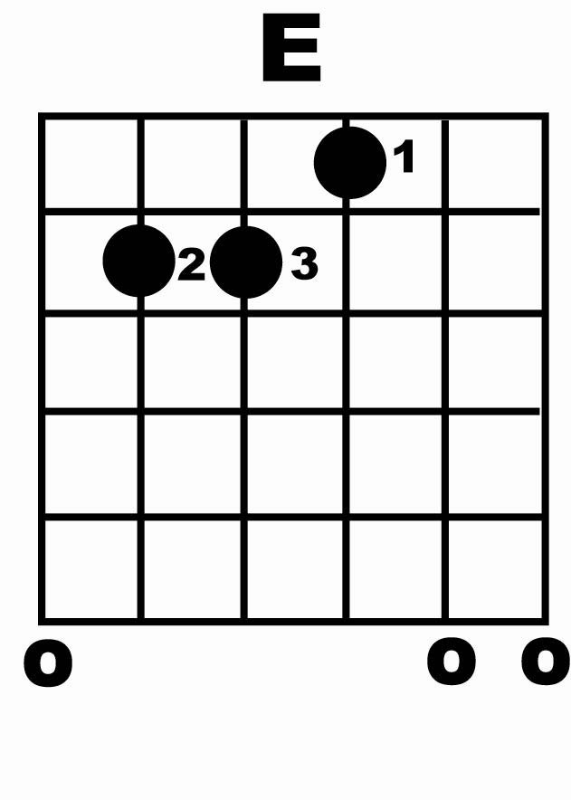
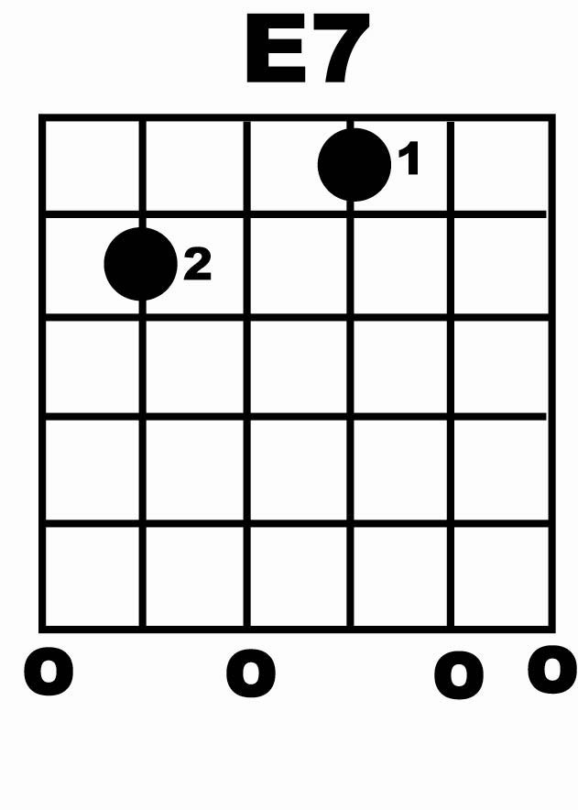
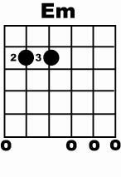

“X”’s and “O’s” on chord chart mean:

DO play the O’s
DON’T play the “X’s” in the case of E all strings can be strummed.

Try the chords above and change in and out of them over these rhythm patterns:

6= downstroke 5= upstroke

Em E
       

E7 E
       

Try adding in some upstrokes:

Em E
 

E7 E
 

NOTE:

Make sure all chords sound “clean” i.e, no buzzing from strings etc…if you hear a “buzzing” sounds just practice picking through each string one a time until this goes away.

Keep all the rhythms smooth and even don’t rush the rhythm. Playing rhythm in songs requires a consistent flowing style – so take your time with it.

